Realtime Motion tracking during fMRI Scans at CFMRI

Contents
1. Overview 2
2. Start Realtime (on scanner console) 2
3. Realtime Display (on realtime computer) 2
4. Stop Realtime (on scanner console) 3
5. Data Transfer 3

Overview
The realtime software is capable of tracking head motion during functional MRI scans. The motion parameters are displayed on the screen while the fMRI scan progresses, allowing researchers to make real-time assessment of subject’s motion during the scan and decide if a rescan is necessary due to excessive motion.
The software was originally developed by Jerzy Bodurka at the Laureate Institute for Brain Research. It is written in perl and utilizes the afni real time plugin and the Dimon command.

Start Realtime (on scanner console)
  - On the scanner console, open a command window. Position the window in the lower right corner of the screen so it does not obstruct any functional areas of the screen.
  - In the command window type: RTctrl start
Note: make sure that command output says “ Real time running”.
  - Register a new patient and Start Exam. Follow the standard procedures to run the MRI scans.
Note: Realtime must be started before Start Exam for it to work.
Optional: Realtime creates a log file under ~sdc/RTafni/var/log . You can monitor the running of the realtime by displaying the log file. Use the following command to display the log file:
tail –f ~sdc/RTafni/var/log/logSince_<month_day_year_id>

Realtime Display (on realtime computer)
  - The realtime motion tracking will be displayed on the realtime computer . Make sure the realtime computer is ON and the monitor is ON.
  - An AFNI window will popup automatically after the first localizer scan finishes, displaying the localizer images. As MRI images being generated on the scanner, the AFNI window will be updated with the new images.
  - For functional scans, shortly after each functional scan starts, the time course will be shown in the AFNI window. Additionally, 6 motion parameters (three translations and three rotations) will be displayed in a graph as shown in the figure below.
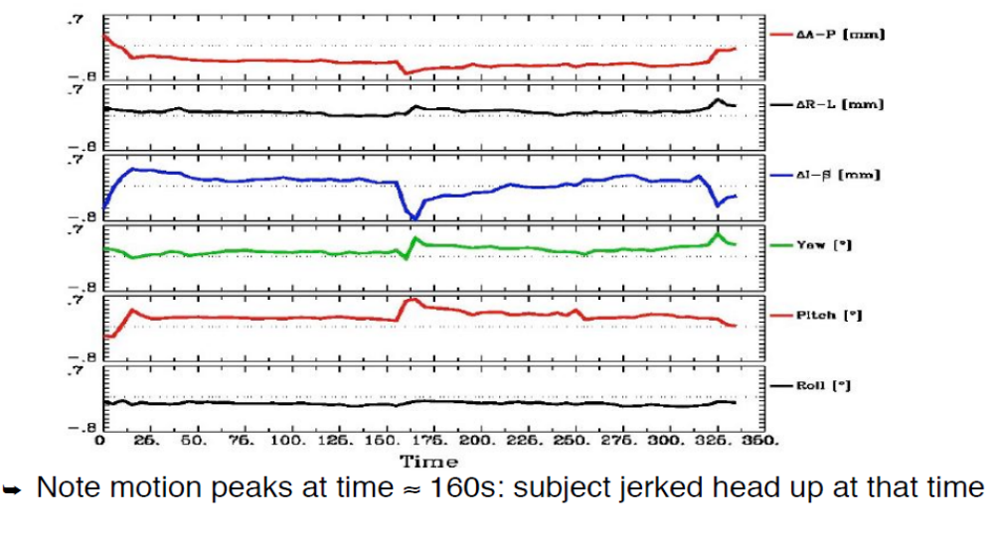
  - The realtime data is saved under /data0/rt/ on the realtime computer. Each exam directory name starts with E following by a system generated number. Look for the most recent E<num> directory which contains the current exam data.

Stop Realtime (on scanner console)
  - End exam on the console computer
Note: The exam must be ended first before stopping the realtime.
  - In the command window, type: RTctrl stop
Note: Confirm the command output says “ Real time is not running”.
  - Close all open command windows

Data Transfer
  - On the scanner console: use gecopy to transfer the dicom data.
  - On the realtime computer: use scp to transfer the realtime data. The data is located in /data0/rt/E<num>

